

School of Computing, Engineering and Built Environment

BIG DATA

Coursework 2:

Support Vector Machine And Neural Network Models To Predict Severity And Causative Factors of Accidents In Nigeria

SUBMITTED ON 10TH, DECEMBER, 2023

Author: Student Number:
Ganiyat Adekunle S2110996

1. Introduction 3
1.1 Problem Statement 3
1.2 Motivation 3
1.3 Key Questions 3
1.4 Predictions 4
1.5 Data Collection 4
2. Data Exploration and Preprocessing 5
2.1 Datasets Consolidation 5
2.2 Understanding Data Characteristics 6
2.3 Identifying Patterns and Outliers (Visualization) 9
2.3.1 Correlation Matrix Visualization 9
2.3.2 Severity Distribution Bar Chart 10
2.3.3 Accidents by State Bar Chart 11
2.3.4 Distribution of Causative Factors Across States 12
2.3.5 Frequency of Bad Road as a Causative Factor 13
2.4 Data Augmentation and Integration 14
2.5 Feature Selection/Extraction 15
2.6 Feature Engineering and Scaling 16
2.6.1 Feature Engineering 16
2.6.2 Feature Scaling and Normalization 17
2.7 Data Exploration and Preprocessing Cases 18
2.8 Significance of Data Preprocessing 18
3. Model Selection: SVM 20
3.1 Support Vector Machine (SVM) 20
3.1.1 Justification for Choosing SVM 20
3.2 Neural Network 21
3.2.1 Justification for Using Neural Network: 21
4. Model Training 22
4.1 Support Vector Machine (SVM) Model Training 22
4.2 Neural Network (NN) Model Training 23
5. Model Evaluation 25
5.1 Support Vector Machine (SVM) Model Evaluation 25
5.1.1 SVM1 Result Analysis 26
5.1.2 Overall Analysis: 27
5.2 Neural Network (NN) Model Training 27
5.2.1 NN Result Analysis 29
6. Hyperparameter Tuning 31
6.1 SVM Model tuning 31
6.1.1 Result Analysis: 32
6.1.2 Conclusion 33
6.2 NN Model tuning 34
6.2.1 Result Analysis 35
6.2.2 Comparison with Initial NN Model1 35
6.2.3 Recommendation 35
6.2.4 Conclusion 36
7. Conclusion 37
8. References 38
9. Appendix 39

1. Introduction
Transportation and logistics play a pivotal role in any society, and understanding the factors influencing highway traffic accidents is crucial for safety and efficiency. According to multiple sources, there is a rising trend in the number of road traffic accident (RTA)-related injuries and fatalities in Nigeria. The mortality rate on the African continent is notably affected by these incidents. Road traffic accidents have risen to become the third-leading cause of death in Nigeria, accounting for the majority of trauma-related fatalities and the most common cause of disability (Onyemaechi and Ofoma 2016). According to the World Health Organization (WHO), Nigeria has a concerning statistic of 1042 deaths per year per 100,000 vehicles, ranking it among the countries with the highest rates of road-related fatalities worldwide. The rising prevalence of RTA in Nigeria and other developing countries has serious physical and socioeconomic consequences, as evidenced by statistics.

Thus, the need for accurate prediction of traffic accident severity to allow for proactive measures, leading to a safer and more resilient transportation system. The aim of this project is to construct Support Vector Machine (SVM) and Neural Network (NN) models as predictors to shed light on the severity and causative factors of highway traffic accidents across states in Nigeria.

1.1 Problem Statement
Despite advancements in transportation safety measures, highway accidents continue to pose a significant challenge. The need to predict accident severity is paramount, as it enables authorities to allocate resources efficiently, implement targeted interventions, and ultimately reduce the impact of accidents on individuals and infrastructure.
The goal is to construct predictive models using Support Vector Machine (SVM) and Neural Network (NN) algorithms to enhance the understanding and prediction of key parameters in highway traffic accidents.

1.2 Motivation
Accurate prediction of traffic accident severity and understanding the contributing factors are crucial for effective transportation and logistics management. By leveraging machine learning models, we aim to provide insights that can aid in developing proactive measures to mitigate accidents and their impacts.

1.3 Key Questions
This analysis aims to answer the following questions:
- What are the primary causative factors contributing to highway traffic accidents in each state?
- How do these causative factors correlate with the severity of accidents?
- Can we predict the severity of accidents based on these causative factors?
- How do different states compare in terms of accident severity and causative factors?
- Are there patterns or trends that emerge from the analysis of the datasets?
- Can the severity of highway traffic accidents be effectively predicted using SVM and NN models?

1.4 Predictions
- The SVM and NN models will provide insights into the significant causative factors influencing accidents in each state.
- Accurate predictions of accident severity levels will be made, enabling proactive measures for risk mitigation.
- Comparative analysis will reveal variations in accident patterns among states, aiding targeted interventions.
- The models will uncover hidden patterns, contributing to a comprehensive understanding of the transportation landscape in Nigeria.

1.5 Data Collection
The analysis was performed on two related datasets, namely transport.csv and causativefactors.csv. The datasets were sourced from the Nigerian Bureau of Statistics, encompassing highway traffic accident information across states in Nigeria. Originally structured in quarterly tables spanning from 2020 to 2023, a significant data preprocessing effort was undertaken to aggregate the information by the "STATE" variable.
The transformation involved grouping the tables by "STATE" and consolidating the data by summing the respective columns. This process aimed to provide a more consolidated and manageable dataset for predictive modeling.
The decision to focus on state-level aggregation stems from the importance of understanding regional variations in accident severity and causative factors. By grouping the data in this manner, we aim to capture the unique dynamics of each state's transportation landscape.

2. Data Exploration and Preprocessing
Data exploration and preprocessing play pivotal roles in the success of any machine learning project. In the context of our datasets, which encapsulate information on the severity and causative factors of highway traffic accidents across states in Nigeria, a meticulous approach to understanding, cleaning, and transforming the data is imperative. This section provides an in-depth exploration of the datasets, outlines the exploration and preprocessing steps taken, and discusses the significance of each.

2.1 Datasets Consolidation
The datasets contain multiple tables with repeated column names for each quarter of the year from 2020 - 2023. This makes it difficult to explore or analyse the datasets in their original format. Therefore, the datasets were aggregated by the "STATE" variable. Below are the transport.csv dataset's original and aggregated formats. The same process was followed for the causativefactors.csv dataset.
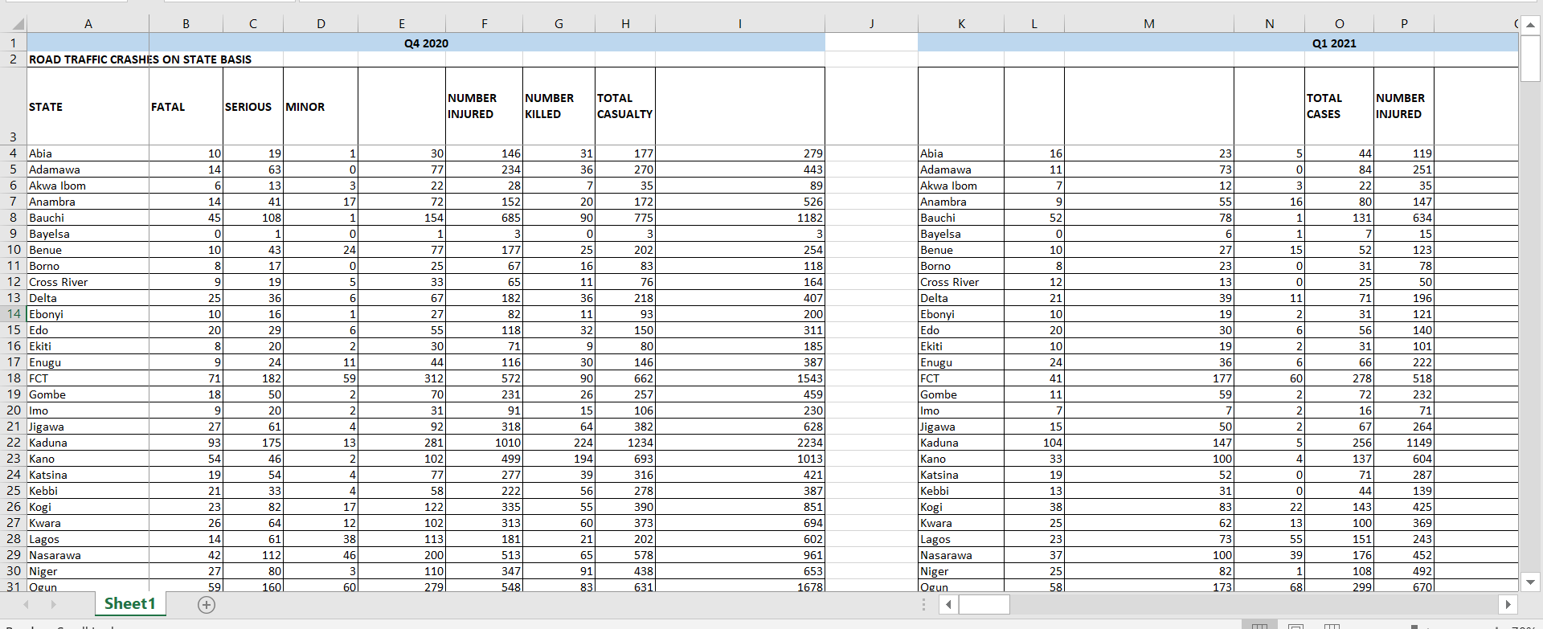
Fig1. transport.csv original dataset format (quarterly tables)

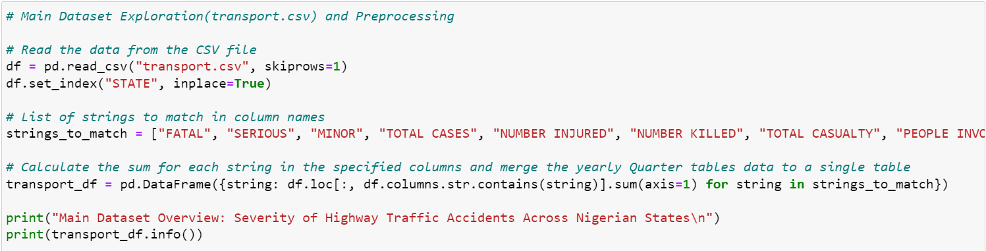
Fig2. Code for aggregating columns

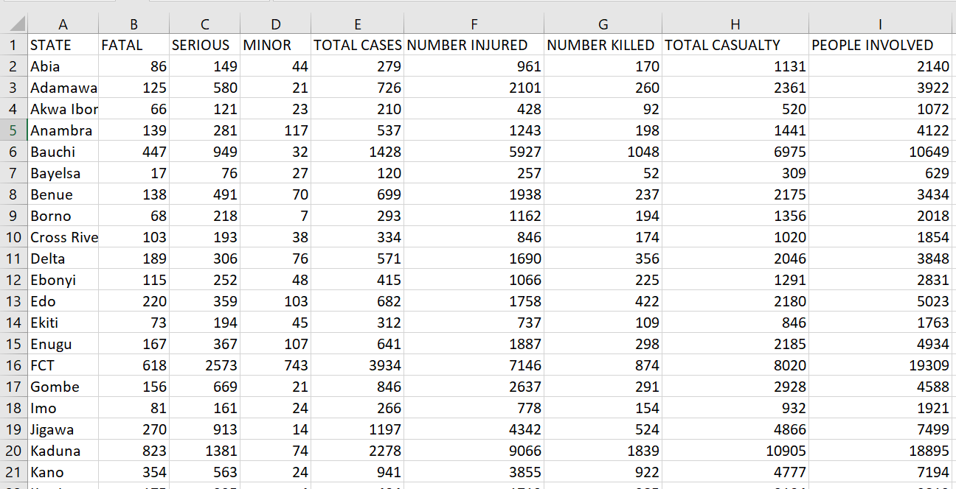
Fig3. transport.csv aggregated dataset format (single table)

2.2 Understanding Data Characteristics
With the datasets consolidated and organized, the next crucial step involves exploring the data to understand its characteristics and addressing any potential challenges.
Transport.csv:
- The transport.csv dataset encompasses information on accident severity across states in Nigeria and consists of
- Initial exploration involved examining key statistics, such as mean, median, and standard deviation, to gain insights into the distribution of accident severity.
- Visualizations, such as histograms and box plots, are employed to identify outliers and patterns within the dataset.
- Missing values were summed, but none were found.
Columns:
  - FATAL: Number of fatal cases
  - SERIOUS: Number of serious cases
  - MINOR: Number of minor cases
  - TOTAL CASES: Total number of cases
  - NUMBER INJURED: Total number of people injured
  - NUMBER KILLED: Total number of people killed
  - TOTAL CASUALTY: Total casualties (injured + killed)
  - PEOPLE INVOLVED: Total number of people involved in the incidents

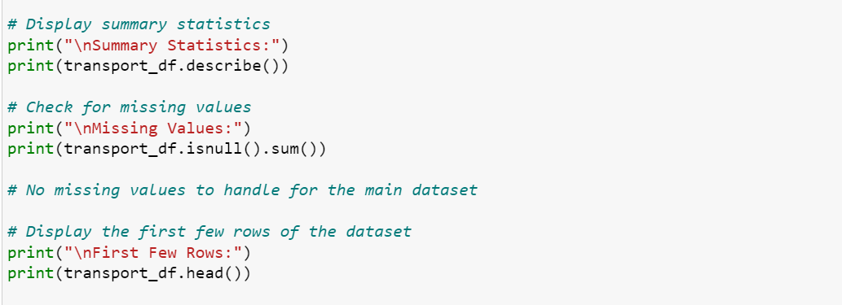
Fig4. Code to display information about transport.csv

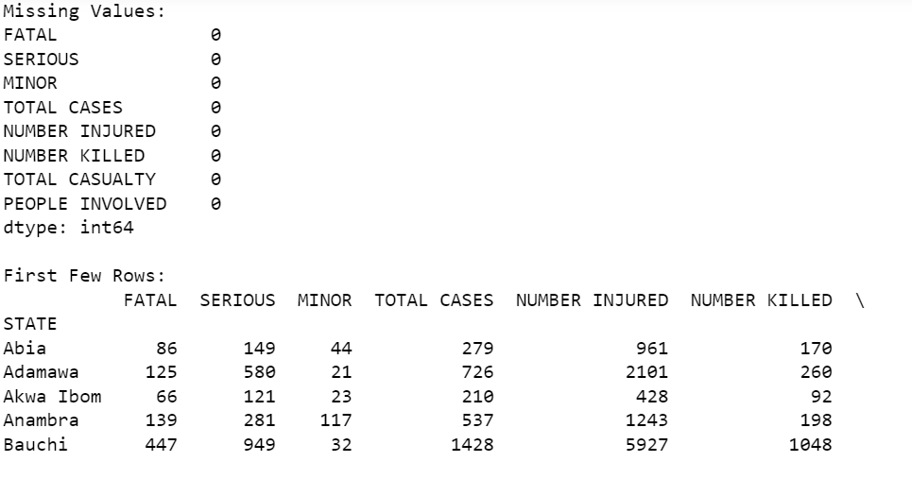
Fig5. Output of missing values, sum, and the first few rows of transport.csv

Causativefactors.csv:
- The causativefactors.csv dataset provides details on factors contributing to accidents in each state and consists of.
- Similar exploratory analyses were conducted to understand the distribution of causative factors.
- Visualizations aided in identifying the prevalence of specific factors and their potential correlation with accident severity.
- No missing or inconsistent values were found.
Columns:
  - SPV: Speeding
  - UPD: Under the influence of Drugs
  - TBT: Tailgating
  - MDV: Mechanical Defects of Vehicle
  - BFL: Bad/Faulty Lights
  - OVL: Overloading
  - DOT: Disobeying Traffic Signs
  - WOT: Wrong Overtaking
  - DGD: Dangerous Driving
  - BRD: Bad Road
  - RTV: Reckless Taxi/Commercial Bus Driver
  - OBS: Obstruction on the Road
  - SOS: Sleeping on Steering
  - DAD: Disobeying Articulated Vehicle Driver
  - PWR: Poor Weather
  - FTQ: Fell-off Tire from moving vehicle
  - SLV: Sleeping on the Leg
  - OTHERS: Other Causes
  - TOTAL: Total number of cases

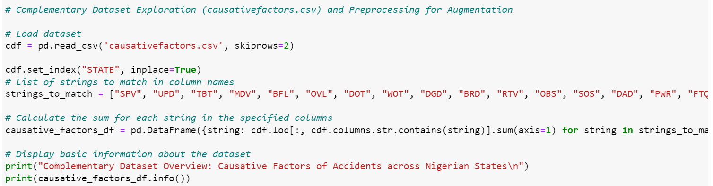
Fig6. Code to aggregate the causativefactors.csv columns

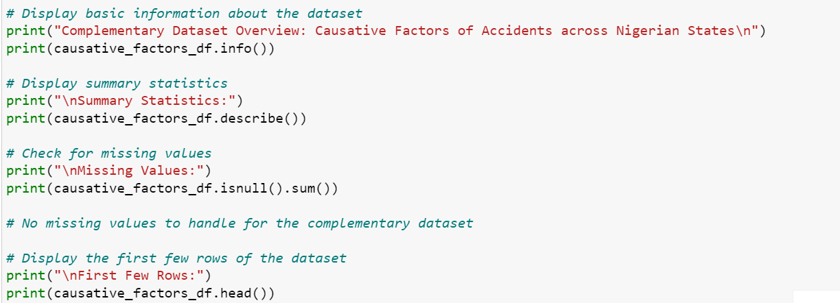
Fig7. Code to display information from causativefactors.csv

2.3 Identifying Patterns and Outliers (Visualization)
Visualizations help identify patterns, outliers, and potential relationships within the datasets, guiding decisions on further preprocessing steps. These visualizations provide insights into the distribution of severity levels and causative factors across different states. The boxplot gives an overview of the variability in severity levels, while the bar plot shows the counts of causative factors. The correlation matrices provide insights into the relationships between different features. Below are the datasets' visualizations and insights.

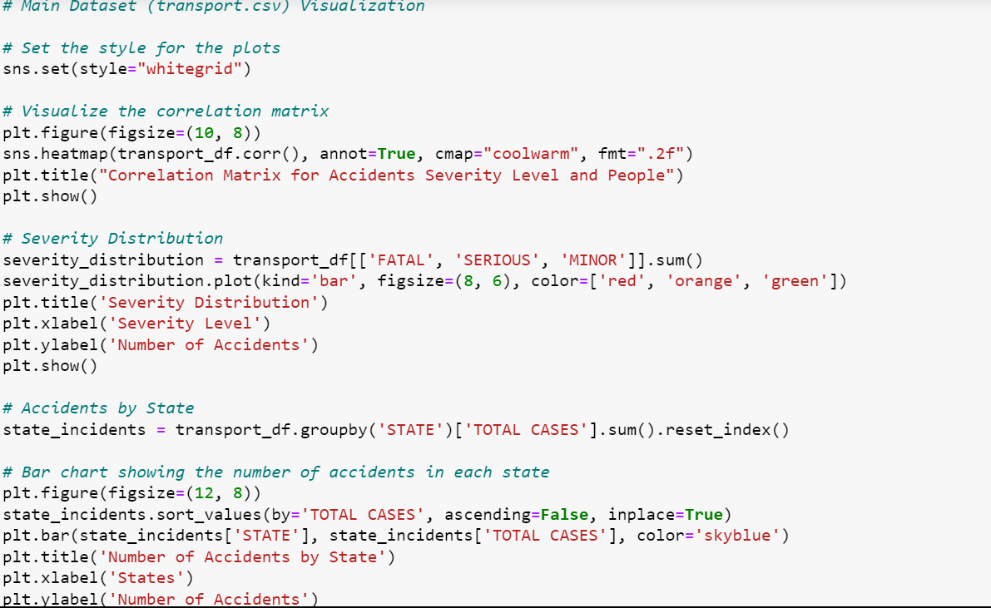
Fig8. Code for transport.csv visualization

2.3.1 Correlation Matrix Visualization
This heatmap illustrates the correlation matrix for accident severity levels and people involved. Positive or negative correlations between variables are indicated by color intensity and shade, respectively. A high correlation between certain features and severity levels suggests their importance in predicting accident outcomes. Analysts can use this information to identify key factors influencing accident severity.
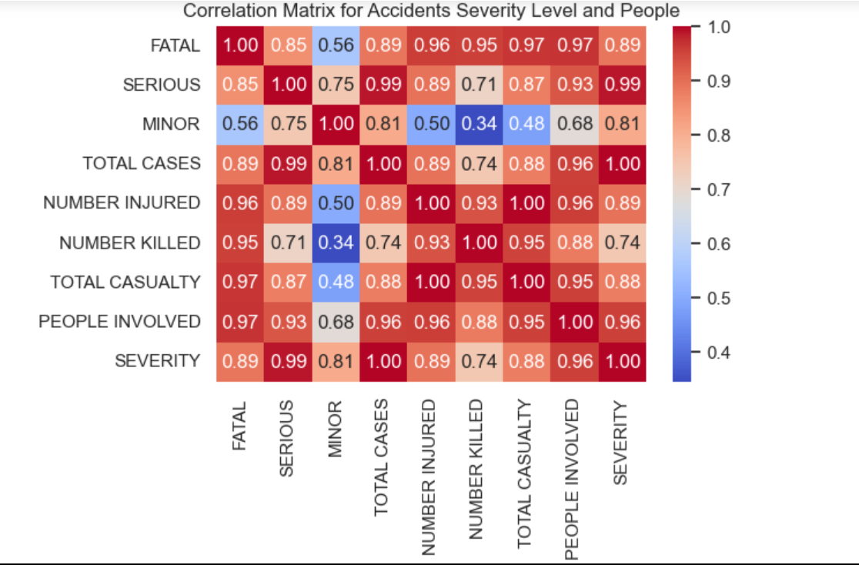
Fig9. Correlation Matrix for Severity of Accidents in Nigeria

2.3.2 Severity Distribution Bar Chart
This bar chart presents a clear distribution of accident severity levels (FATAL, SERIOUS, MINOR). The varying heights of the bars reveal the frequency of each severity level, providing an overview of the dataset's composition. This insight is crucial for understanding the prevalence of different severity levels and can guide the focus of predictive models towards the more critical outcomes.
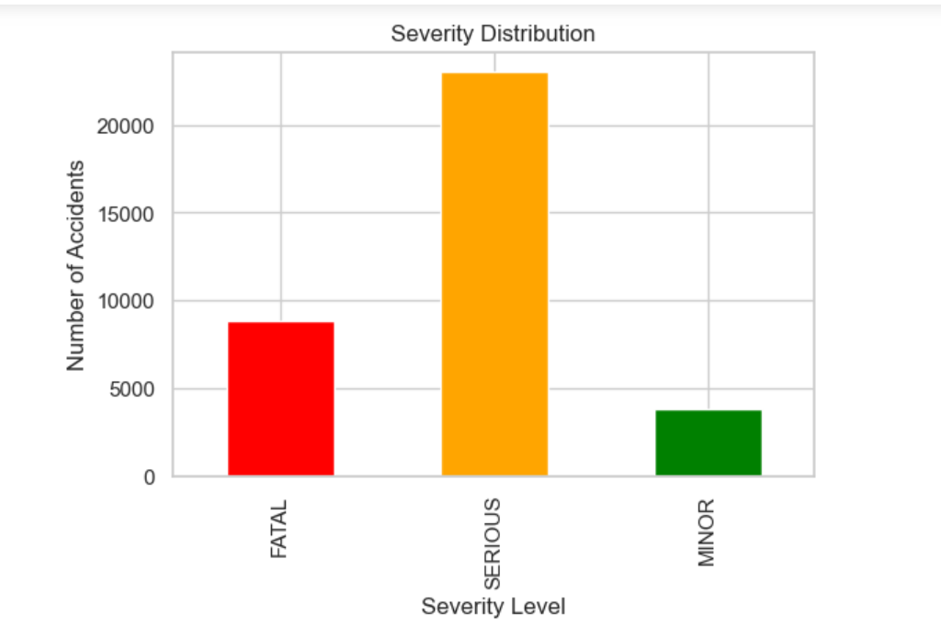
Fig10. Severity Distribution Bar Chart

2.3.3 Accidents by State Bar Chart
By aggregating and visualizing the total number of accidents in each state, this bar chart highlights geographic variations in accident frequency. States with taller bars experience a higher number of accidents. This information is essential for regional prioritization of safety measures and resource allocation. Decision-makers can use this visualization to identify areas with a high incidence of accidents, allowing for targeted interventions and policy implementation.

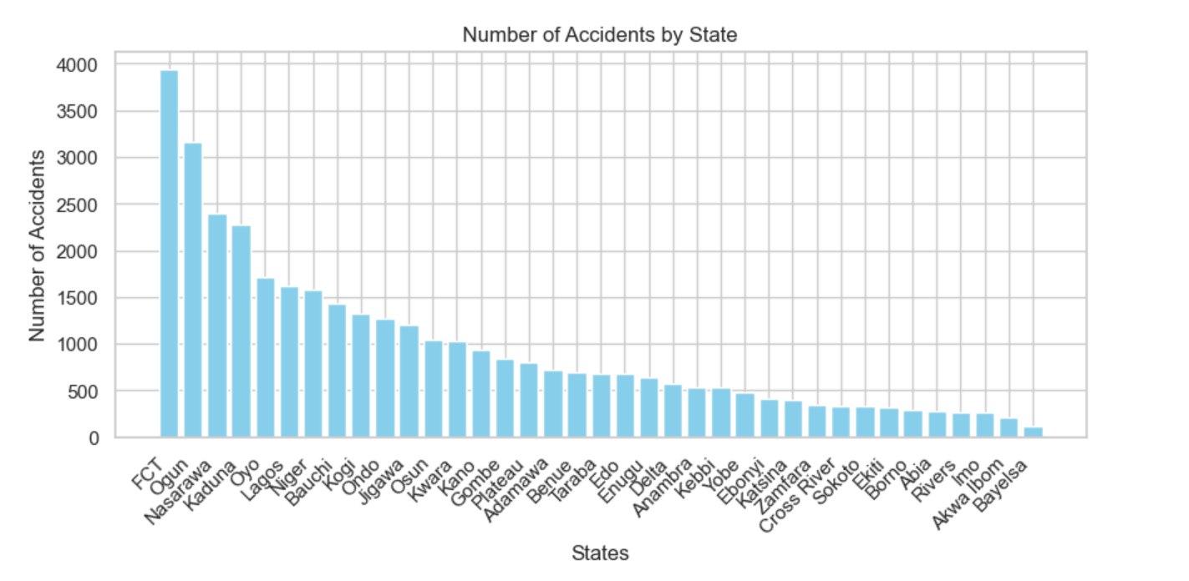
Fig11. Accidents by State Bar Chart

2.3.4 Distribution of Causative Factors Across States
This bar chart provides a visual representation of the distribution of causative factors across different states. Each bar corresponds to a causative factor, and its height represents the count of occurrences. The color palette (viridis) enhances visibility, making it easier to identify prevalent factors. Stakeholders can use this information to prioritize interventions and safety measures based on the most frequent causative factors in specific regions.
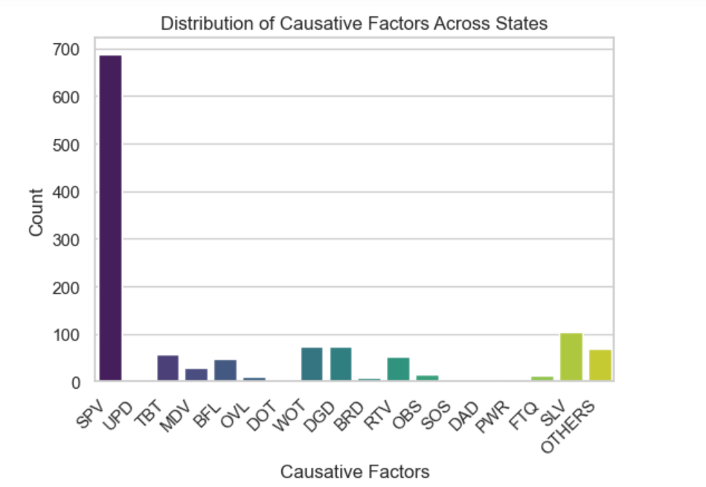
Fig12. Distribution of Causative Factors Across States

2.3.5 Frequency of Bad Road as a Causative Factor
This histogram illustrates the distribution of cases where "Bad Road" (BRD) is identified as a causative factor. The x-axis represents the number of cases, and the y-axis represents the frequency of occurrences. The histogram provides a detailed view of the prevalence of bad road conditions as a causative factor. Decision-makers can use this information to address infrastructure issues and prioritize road maintenance in areas where bad road conditions significantly contribute to accidents.
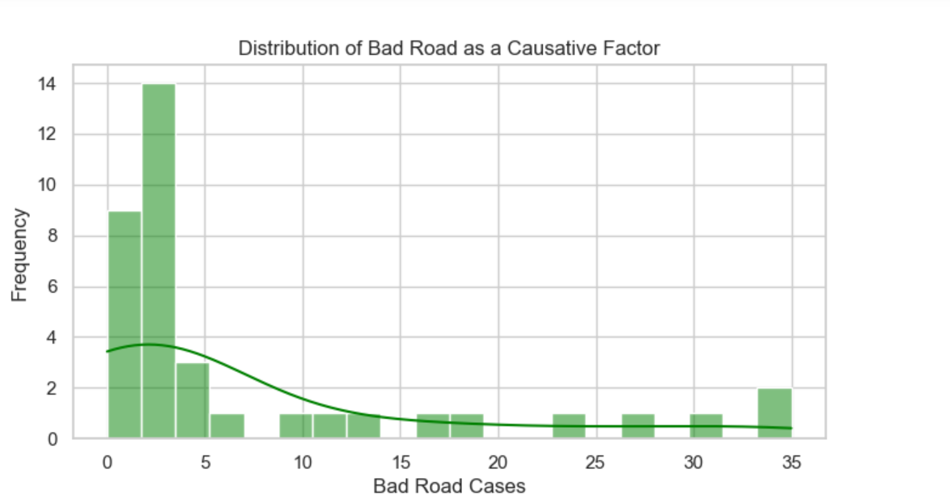
Fig13. Frequency of Bad Road as a Causative Factor

2.4 Data Augmentation and Integration
The datasets were merged based on the common "STATE" variable, creating a comprehensive dataset that combines accident severity and causative factors. By merging these datasets, we seek to create a robust framework for predicting and understanding highway traffic accidents in Nigeria.

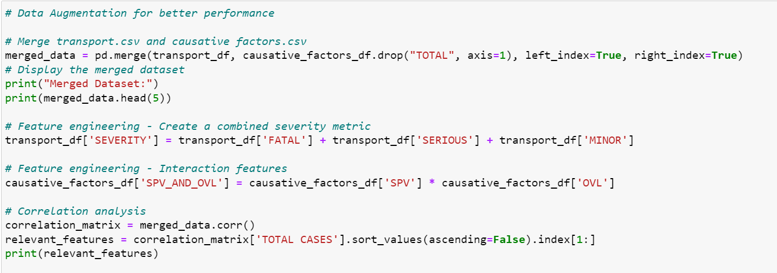
Fig14. Code to merge the two datasets, perform feature engineering and correlation analysis
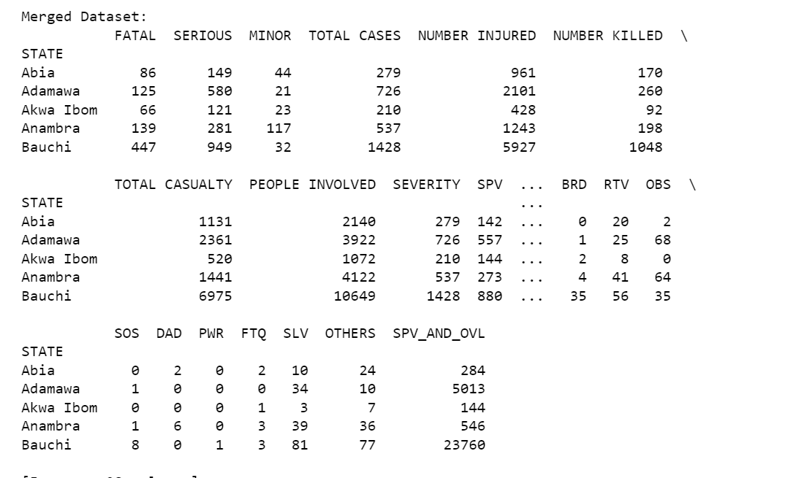
Fig15. Output showing the merged data information

2.5 Feature Selection/Extraction
Feature selection is a critical step in optimizing the performance of the models. It involves identifying and retaining the most relevant features that contribute significantly to the prediction of accident severity. In the context of our datasets, the goal is to enhance the model's accuracy and interpretability.
Identifying Relevant Features:
- Identifying Key Causative Factors:
  - Statistical methods were used to identify the most significant causative factors contributing to accidents in different states. This involved analyzing the feature importance scores.
Fig16. Code for Feature Importance Analysis

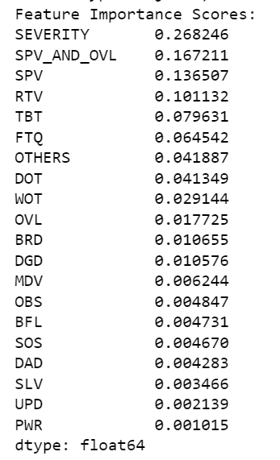
Fig17. Feature importance Scores

- Correlation Analysis:
  - The relationships between causative factors and accident severity were explored by using a Random Forest Regressor to analyze feature importance and a heatmap to visualize correlations.
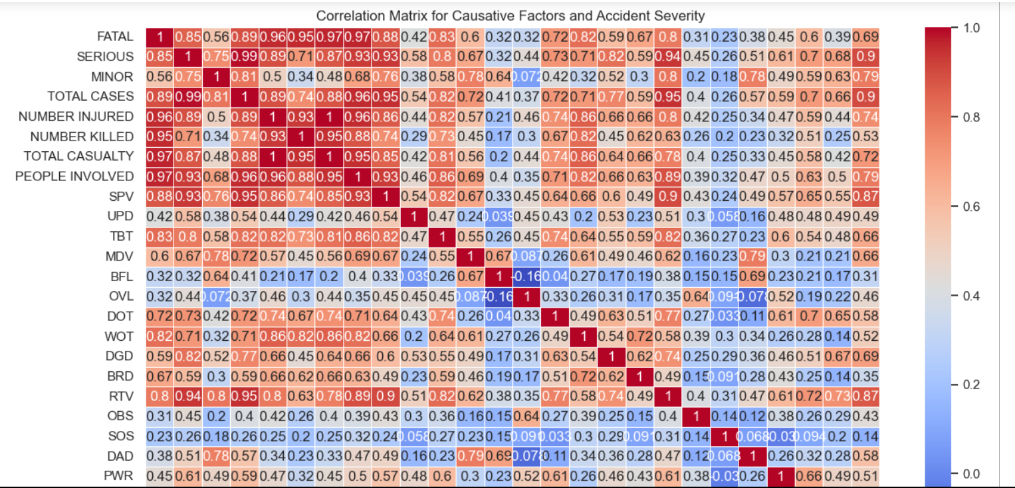
Fig18. Correlation matrix for the merged data

2.6 Feature Engineering and Scaling
Feature engineering, feature scaling, and normalization are techniques commonly considered in machine learning scenarios, but their necessity depends on the requirements of the chosen models. Let's evaluate each in the context of this project:

2.6.1 Feature Engineering
Scenario for Consideration:
- When the existing features may not fully capture the underlying patterns in the data.
- If creating new features or transforming existing ones could enhance the models' performance.
Decision:
- New feature [‘SEVERITY’] was created by combining the three severity levels ‘FATAL’, ‘SERIOUS’, and ‘MINOR’ to enhance the predictive and classification power of the models. This new metric represents the overall severity of accidents and serves as the target variable for the SVM model.

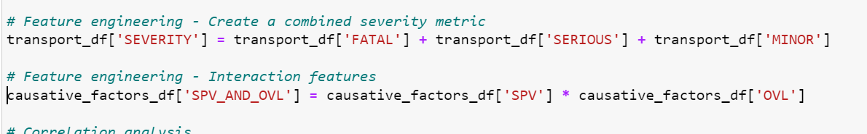
Fig19. Code for Feature Engineering

2.6.2 Feature Scaling and Normalization
Feature scaling was employed to ensure that all features contribute equally to the model training process, preventing the dominance of features with larger magnitudes.
Scenario for Consideration:
- When the magnitude of values in different features varies significantly.
- For algorithms that are sensitive to the scale of input features (e.g., SVM with a radial basis function kernel).
Decision:
- It's often beneficial to apply feature scaling or normalization, especially when using SVM or NN models. In this scenario, we utilize the StandardScaler from scikit-learn to normalize selected columns and features in the merged dataset, including 'TOTAL CASES,' 'NUMBER INJURED,' 'NUMBER KILLED,' 'TOTAL CASUALTY,' and 'PEOPLE INVOLVED,' to ensure uniformity in the input data for the models.
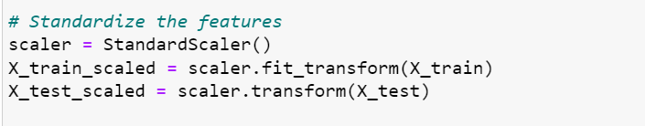
Fig20. Code for standardizing features

By systematically addressing data exploration and preprocessing cases, we have established a robust foundation for our SVM and NN models. The significance of each step lies in its contribution to a clean, reliable, and optimized dataset, setting the stage for meaningful insights and accurate predictions.

2.7 Data Exploration and Preprocessing Cases

 | Cases and Solutions
Consolidation of Quarterly Tables | - Case: The original dataset comprised quarterly tables, making analysis challenging.  - Solution: Tables were grouped by "STATE," and the data was aggregated by summing the respective columns, resulting in a state-wise overview of accidents.
Exploring Accident Severity Distribution | - Case: Understanding the distribution of accident severity is crucial for analysis.  - Solution: Visualizations, including histograms, were employed to explore the distribution of 'TOTAL CASES' and 'TOTAL CASUALTY,' providing insights into the dataset's characteristics.
Feature Scaling and Encoding | - Case: Features with varying scales and categorical variables needed suitable preprocessing.  - Solution: Standard scaling was applied to numerical features like 'NUMBER INJURED,' and the severity levels were one-hot encoded to prepare the dataset for model training.  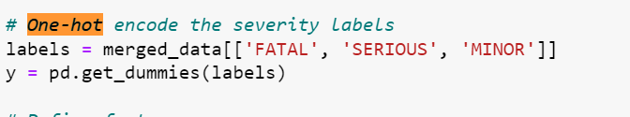  Fig21. One-hot encoding
Table 1 showing Data Exploration and Preprocessing cases

2.8 Significance of Data Preprocessing
The dataset, sourced from the Nigerian Bureau of Statistics, initially presented challenges such as quarterly tables spanning from 2020 to 2023 and repeated columns. Effective preprocessing is essential for several reasons:
Ensuring Data Quality:
  - Rigorous exploration allows the identification and handling of repeated values, ensuring the completeness and reliability of the dataset.
Facilitating Model Training:
  - The dataset is preprocessed to create a clean and well-structured foundation for model training. This involves handling outliers, normalizing features, and addressing any anomalies that could impact the effectiveness of machine learning models.
Enhancing Model Performance:
  - Techniques such as feature scaling and encoding categorical variables are applied to enhance model performance. This is particularly crucial for models sensitive to the scale of input features, such as SVM and NN.

3. Model Selection: SVM

3.1 Support Vector Machine (SVM)
Support Vector Machines aim to find a hyperplane that best separates the data into different classes or predicts a continuous outcome. The hyperplane is chosen in such a way that it maximally separates the classes or fits the regression line. Choosing the right model is pivotal for achieving accurate predictions in a machine learning project. In the context of predicting highway traffic accident severity, the Support Vector Machine (SVM) emerges as a compelling choice for several reasons.

3.1.1 Justification for Choosing SVM
Handling Non-Linearity:
  - SVM is well-suited for problems with non-linear relationships between features and the target variable. In the case of traffic accident severity, the interplay of various causative factors and the severity metric may exhibit complex, non-linear patterns that SVM can effectively capture.
Robustness to Outliers:
  - SVM is robust to outliers, and highway traffic accident data often includes outliers due to exceptional circumstances. The robustness of SVM ensures that these outliers do not unduly influence the model, resulting in a more reliable predictor.
High-Dimensional Space:
  - SVM performs well in high-dimensional spaces, making it suitable for scenarios where multiple features contribute to the prediction of accident severity. With causative factors, temporal features, and engineered features, the dataset becomes a high-dimensional space where SVM can navigate efficiently.
- Versatility of Kernels:
  - SVM offers versatility through the use of different kernels, allowing it to adapt to various data structures. This adaptability is valuable in our case, where the relationships between features and accident severity may not be strictly linear.

Three types of SVM models are trained with different kernels: Linear, Radial Basis Function (RBF), and Polynomial. The selection of these kernels is based on their suitability for the specific characteristics of the data.
Linear Kernel:
- Advantages:
  - Generally faster training times compared to non-linear kernels.
  - Effective when the relationship between features and target is approximately linear.
- Considerations:
  - May not capture complex, non-linear patterns as effectively as the RBF kernel.
RBF Kernel:
- Advantages:
  - Captures complex, non-linear relationships in the data.
  - Flexible and versatile for a wide range of patterns.
- Considerations:
  - Training time may be longer, especially for larger datasets.
Polynomial Kernel:
- Advantages:
  - Capture Polynomial Relationships.
  - Computationally Feasible.
- Considerations:
  - Increased Complexity.
  - Training Time may be longer.

The comparison allows for a nuanced understanding of how different kernel choices impact model performance. The linear kernel might excel in scenarios where simplicity is key, while the RBF kernel shines in capturing intricate relationships.

3.2 Neural Network
A Neural Network (NN) is a computational model inspired by the structure and functioning of the human brain. It consists of interconnected nodes, or artificial neurons, organized into layers. The fundamental building blocks are the input layer, hidden layers, and output layer. Each connection between neurons is associated with a weight, and the network learns to adjust these weights during training to optimize its performance.
In the context of this project on predicting the severity of highway traffic accidents in Nigeria, a neural network is a suitable choice for several reasons.

3.2.1 Justification for Using Neural Network:
- Predictive Power: Neural networks are known for their high predictive power, especially in scenarios where the underlying relationships are intricate and non-linear. The initial neural network result in our project demonstrates perfect accuracy on the test set, showcasing its potential for accurate predictions.
- Adaptability to Data Complexity: The dataset involving highway traffic accidents is inherently complex, with numerous contributing factors. A neural network's adaptability to handle this complexity makes it a suitable candidate for the task.
- Automatic Feature Learning: The feature importance scores provided by the RandomForestRegressor in the code demonstrate the significance of various causative factors. Neural networks, through automatic feature learning, can further enhance the model's understanding of these features and their impact on accident severity.
- Potential for Improvement: While the initial neural network result is promising, it also reveals a need for further refinement, especially when transitioning to the augmented neural network. This suggests that with careful tuning and optimization, neural networks have the potential to further improve their performance on the given task.

4. Model Training

4.1 Support Vector Machine (SVM) Model Training
- Split the Dataset
The first step in training an SVM model is to divide the dataset into training and testing sets. This is achieved in the code using the train_test_split function from the sklearn.model_selection module. Specifically, the merged dataset, which combines information from transport.csv and causativefactors.csv, is split into features (X) and the target variable (y), representing the total number of accidents (‘TOTAL CASES’). The dataset is divided into training and testing sets with an 80-20 split ratio.
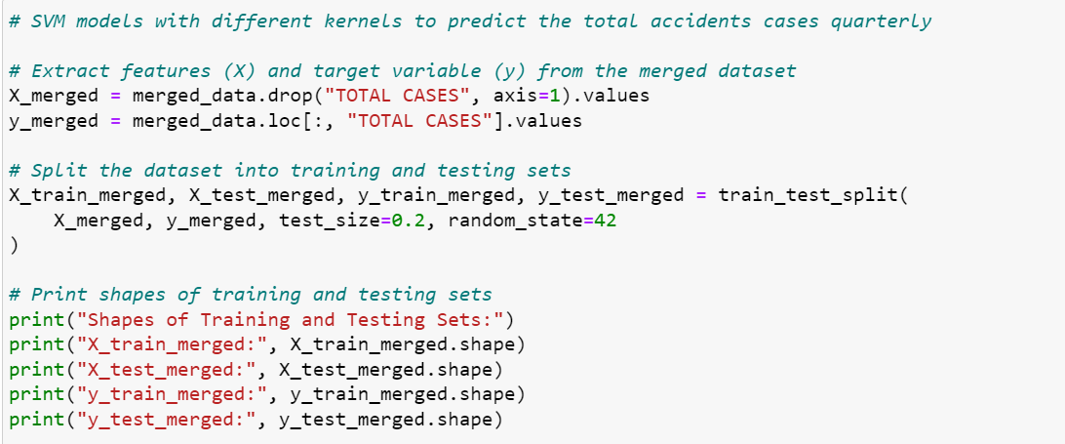
Fig21. Code to extract features and split dataset

- Choose Appropriate Kernel and Hyperparameters: The SVM model's choice of kernel and hyperparameters significantly influences its performance. In the code, three types of SVM models are trained with different kernels: Linear, Radial Basis Function (RBF), and Polynomial. The selection of these kernels is based on their suitability for the specific characteristics of the data. Hyperparameter tuning is essential for optimizing the model's performance. In the code below, the default hyperparameters are used, but further tuning was applied to enhance the model.

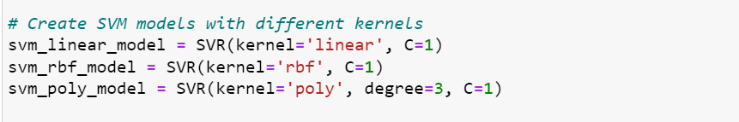
Fig22. Code to create an SVM model with different kernels

- Train the SVM Model: After splitting the data and selecting the appropriate kernel and hyperparameters, the SVM model is trained on the training set. The fit method is employed, where the model learns the patterns and relationships within the training data to make accurate predictions.
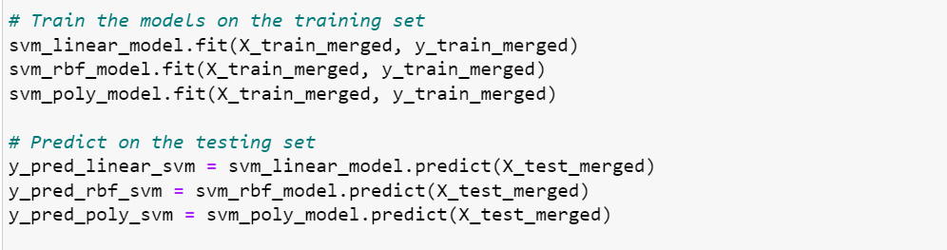
Fig23. Code to train SVM models

The code establishes the foundation for subsequent model evaluation and analysis by splitting the dataset, choosing appropriate kernels, and training the SVM model on the training set. The choice of kernels and hyperparameters is further fine-tuned for optimal performance in real-world applications.

4.2 Neural Network (NN) Model Training
1. Splitting the Dataset:
As in training an SVM model, the first step to training an NN model is to split the dataset into training and testing sets. This is crucial for assessing how well the model generalizes to unseen data. Here's the relevant code:

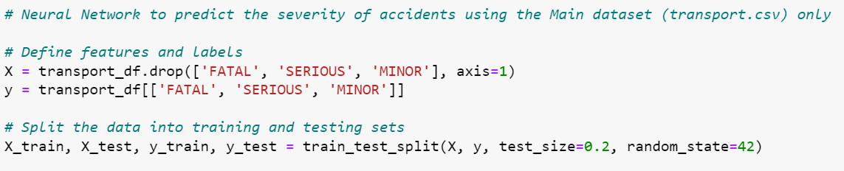
This code uses scikit-learn's train_test_split function to divide the features (X) and labels (y) into training and testing sets. The test_size=0.2 parameter indicates that 20% of the data is reserved for testing.
2. Scaling Features:
It's a common practice to scale numerical features before feeding them into a neural network. Scaling ensures that all features have a similar scale, preventing some features from dominating others. The StandardScaler is used to standardize the features based on the mean and standard deviation of the training set. The fit_transform method is applied to the training set, and the same transformation is applied to the testing set using the transform method.
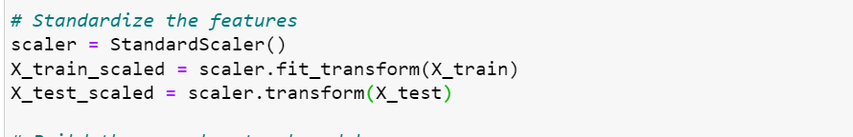
Fig24. Code to standardize features

3. Building the Neural Network Model:
The neural network model is defined using TensorFlow's Keras API. The model consists of one hidden layer with 64 neurons and a ReLU activation function, followed by an output layer with 3 neurons (for FATAL, SERIOUS, and MINOR) and a softmax activation function:
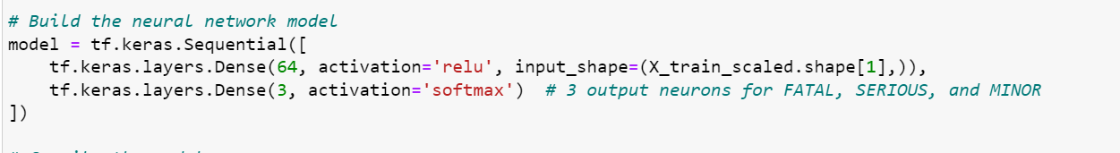
Fig25. Code to build neural network model

4. Compiling the Model:
Before training, the model needs to be compiled. This involves specifying the optimizer, loss function, and metrics to monitor during training. The chosen optimizer is 'adam,' the loss function is 'categorical_crossentropy' since this is a multiclass classification problem, and the metric to monitor is 'accuracy.'
Fig26. Code to compile model

5. Training the Model:
The neural network is trained using the training data. The fit method was used to train the model. The epochs parameter specifies the number of times the model will iterate over the entire training set. The batch_size indicates the number of samples used in each iteration. The validation_data argument allows monitoring the model's performance on the testing set during training.
Fig27. Code to train the NN model

5. Model Evaluation

5.1 Support Vector Machine (SVM) Model Evaluation
The evaluation of the SVM model involves assessing its performance on the testing set using various metrics. The Mean Squared Error (MSE) metric, which measures the average squared difference between the predicted and actual values; the Root Mean Squared Error (RMSE), which is the square root of MSE, providing a more interpretable measure of the model's prediction error; the R-squared (R2), which is a statistical measure of the proportion of the variance in the dependent variable that is predictable from the independent variable(s); and the Mean Absolute Error (MAE), which is the average absolute difference between the predicted and actual values, were the metrics used for evaluating the SVM model. A baseline model was also created to compare the performance of the model with it.
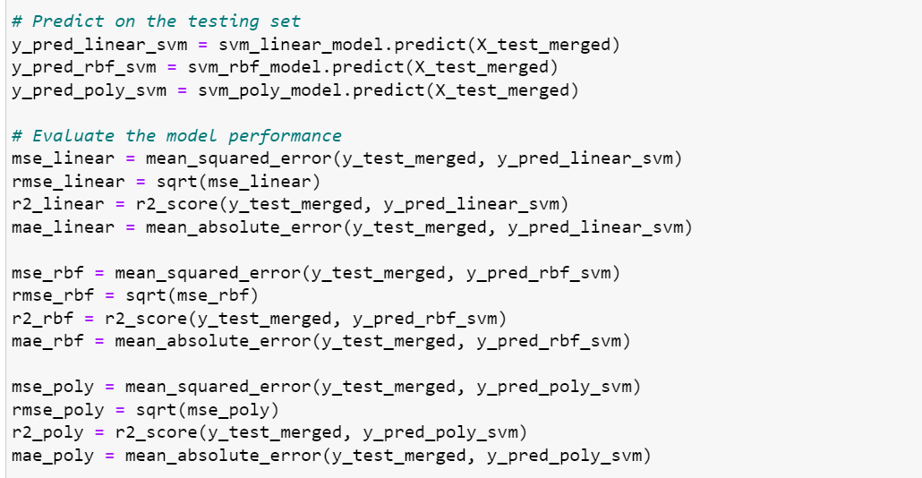
Fig28. Code to evaluate the SVM model

SVM Result:
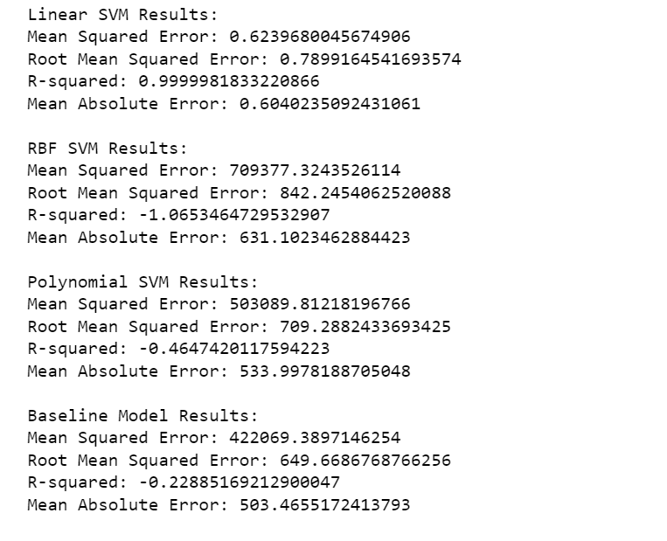
Fig29. SVM Model 1 Result

5.1.1 SVM1 Result Analysis
Linear SVM Results:
- Mean Squared Error (MSE): 0.624
- Root Mean Squared Error (RMSE): 0.790
- R-squared (R²): 0.999998
- Mean Absolute Error (MAE): 0.604
The linear SVM model demonstrates an exceptionally high R-squared value close to 1, indicating an almost perfect fit to the data. The low values of MSE, RMSE, and MAE further suggest that the model's predictions closely align with the actual values. This indicates that the linear SVM model performs exceptionally well and captures the underlying patterns in the data.
RBF SVM Results:
- Mean Squared Error (MSE): 709377.324
- Root Mean Squared Error (RMSE): 842.245
- R-squared (R²): -1.065
- Mean Absolute Error (MAE): 631.102
The RBF (Radial Basis Function) SVM model, on the other hand, exhibits poor performance. The high MSE, RMSE, and MAE values, coupled with a negative R-squared, suggest that this model struggles to capture the variability in the data. It might be overfitting or inadequately modeling the complex relationships within the dataset.
Polynomial SVM Results:
- Mean Squared Error (MSE): 503089.812
- Root Mean Squared Error (RMSE): 709.288
- R-squared (R²): -0.465
- Mean Absolute Error (MAE): 533.998
The polynomial SVM model also demonstrates suboptimal performance, as evidenced by the high MSE, RMSE, and MAE values. The negative R-squared indicates that this model is not capturing the variance in the data effectively. It might be overly complex, leading to poor generalization.
Baseline Model Results:
- Mean Squared Error (MSE): 422069.39
- Root Mean Squared Error (RMSE): 649.669
- R-squared (R²): -0.229
- Mean Absolute Error (MAE): 503.466
Baseline Model Results (using Median):
- Mean Squared Error (MSE): 719848.75
- Root Mean Squared Error (RMSE): 848.439
- R-squared (R²): -1.096
- Mean Absolute Error (MAE): 636.25
Both baseline models (using mean and median) also display poor performance, with high MSE, RMSE, and MAE values, along with negative R-squared values. These results emphasize the need for a more sophisticated model than a simple baseline.

5.1.2 Overall Analysis:
- The linear SVM model outperforms both the RBF and polynomial SVM models, as well as the baseline models. Its ability to closely match the observed values suggests that it is a strong candidate for predicting the severity of highway traffic accidents in Nigeria.
- The RBF and polynomial SVM models, along with the baseline models, show limitations in capturing the underlying patterns in the data. Further model refinement or feature engineering might be necessary to enhance their predictive capabilities.
In conclusion, the choice of kernel significantly impacts the SVM model's performance, with the linear kernel showing superior results. The results also highlight the importance of careful model selection and hyperparameter tuning in achieving accurate predictions for the given dataset.

5.2 Neural Network (NN) Model Training
After training, the model is evaluated on the testing set to assess its performance. The test loss and accuracy are then printed, providing insights into how well the model generalizes to new, unseen data. The one-hot coded predictions were converted to categorical labels, and a function was created to evaluate the model based on accuracy score, precision score, recall, F1 score, and confusion matrix. The confusion matrix is then plotted, and the first five predictions are displayed.
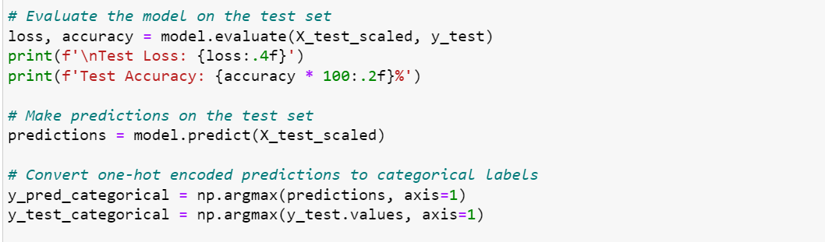
Fig30. Code to evaluate the NN model

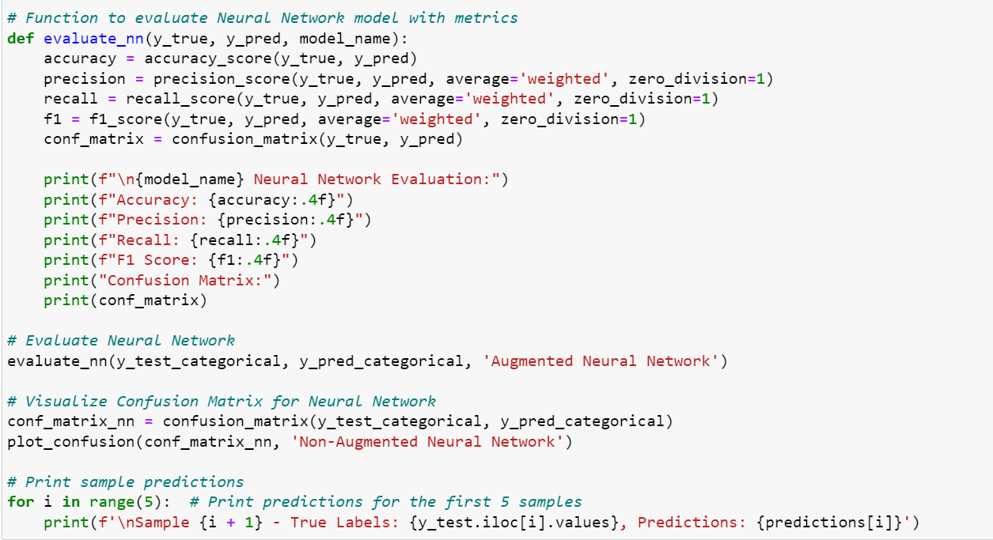
Fig31. Code for additional evaluation

5.2.1 NN Result Analysis
Result:
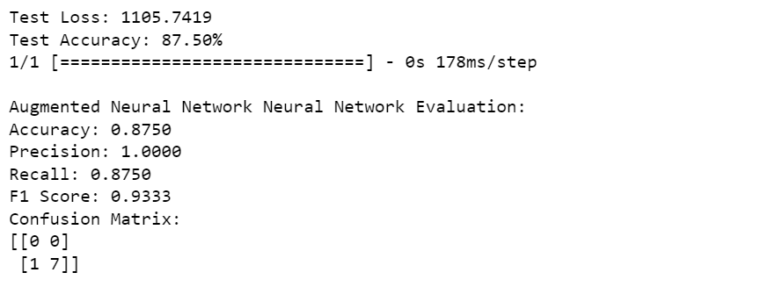
Fig32. NN Model 1 result

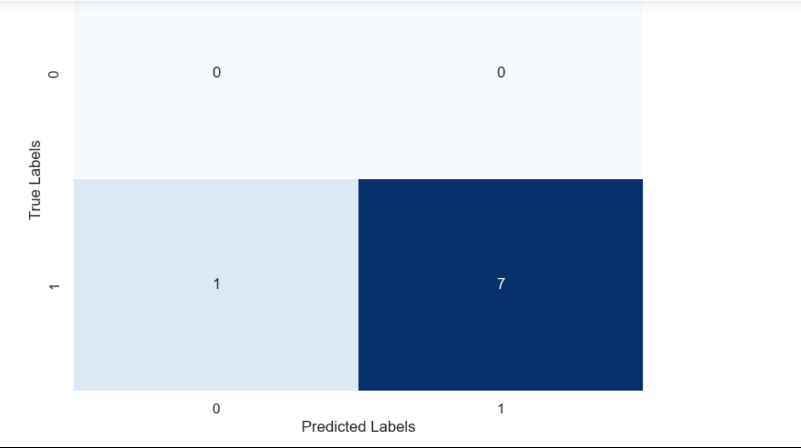
Fig33. NN Model 1 Confusion matrix

The results of the neural network (NN) model are as follows:
- Test Loss: 1105.7419
  - The test loss represents the difference between the predicted values and the actual values. In this case, the test loss is relatively high, indicating that there is a considerable difference between the predicted and actual values.
- Test Accuracy: 87.50%
  - Test accuracy is a measure of how well the model performs on the test dataset. An accuracy of 87.50% suggests that the model correctly predicted the outcomes for 87.50% of the samples in the test set.
- Precision: 1.0000
  - Precision is the ratio of correctly predicted positive observations to the total predicted positives. A precision of 1.0000 indicates that when the model predicts a positive outcome, it is highly likely to be correct.
- Recall: 0.8750
  - Recall, also known as sensitivity or true positive rate, is the ratio of correctly predicted positive observations to the actual positives. A recall of 0.8750 means that the model identified 87.50% of the actual positive cases.
- F1 Score: 0.9333
  - The F1 score is the harmonic mean of precision and recall. It provides a balance between precision and recall. An F1 score of 0.9333 is generally considered good, indicating a balanced performance.
- Confusion Matrix:
  - The confusion matrix provides a detailed breakdown of the model's predictions. In this case:
    - True Negative (TN): 0
    - False Positive (FP): 0
    - False Negative (FN): 1
    - True Positive (TP): 7
- The confusion matrix shows that the model made one false negative prediction, indicating that one actual positive instance was incorrectly classified as negative. However, it correctly classified seven positive instances.
Analysis:
- The high test loss suggests that there might be room for improvement in the model's predictive performance.
- The accuracy of 87.50% is decent, but it's essential to consider other metrics like precision, recall, and F1 score for a more comprehensive evaluation.
- The model's precision of 1.0000 is impressive, indicating a low rate of false positives.
- The recall of 0.8750 suggests that the model is capturing a substantial portion of the actual positive cases.
- The F1 score of 0.9333 is encouraging, indicating a good balance between precision and recall.

6. Hyperparameter Tuning
Both the SVM and NN models were tuned to enhance the models' performance. The change in the model's performance can be found below:

6.1 SVM Model tuning
In the SVM model, hyperparameter tuning is a crucial step to optimize the model's performance. Here's an explanation of the hyperparameter tuning process:
- Grid Search:
  - Grid search is a systematic method for hyperparameter tuning that evaluates a predefined set of hyperparameter values.
  - The scikit-learn library provides the GridSearchCV function, which performs an exhaustive search over a specified parameter grid.
- Parameters Considered:
  - For the SVM model, key hyperparameters include the choice of kernel and the regularization parameter (C).
  - Kernels: Linear, Radial Basis Function (RBF), and Polynomial.
  - Regularization Parameter (C): Controls the trade-off between achieving a smooth decision boundary and classifying training points correctly.
- Implementation in Code:
  - The following code snippet illustrates the implementation of hyperparameter tuning for the SVM model:

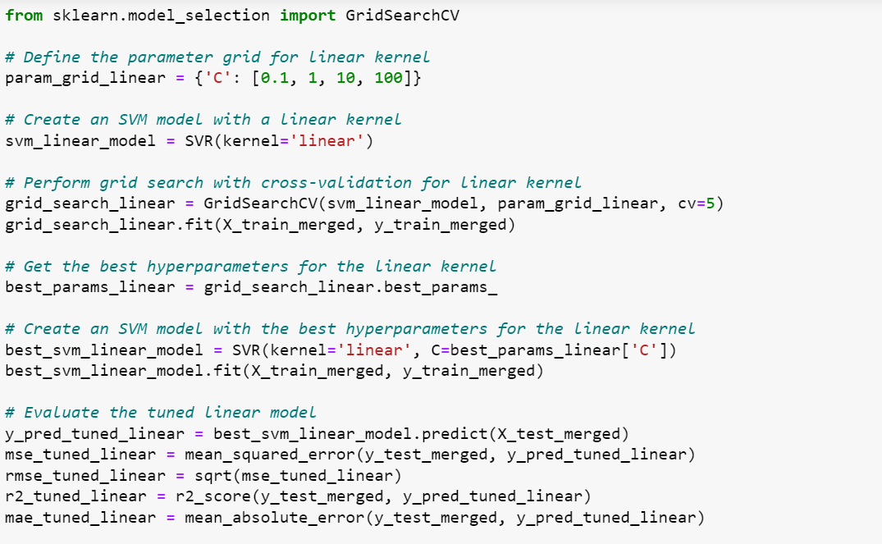
Fig34. Code for SVM hyperparameter tuning

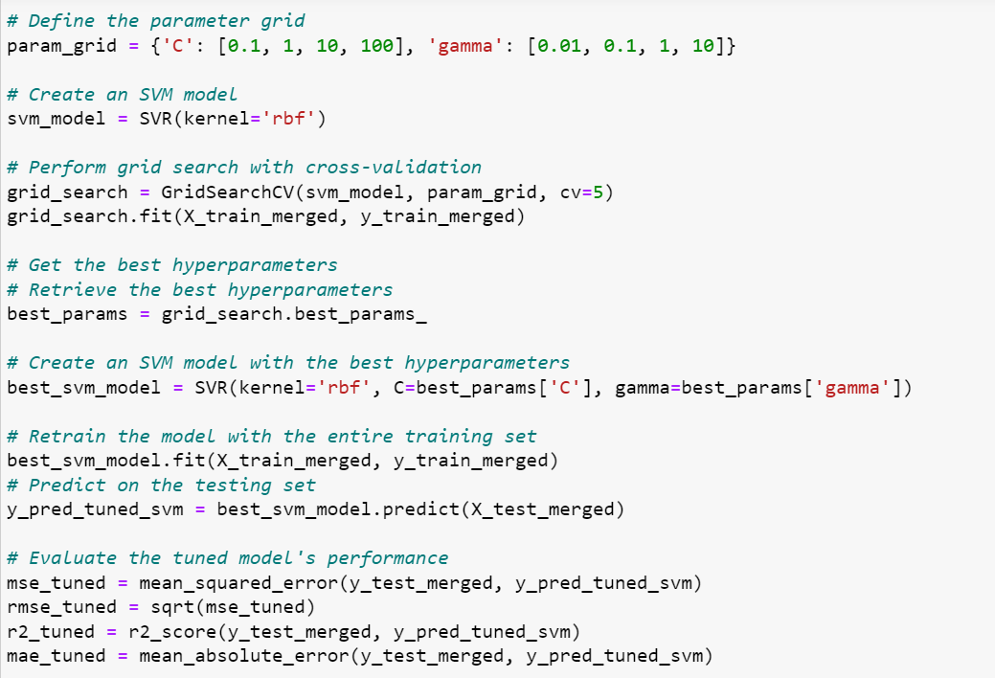
Fig35. Code for SVM hyperparameter tuning contd

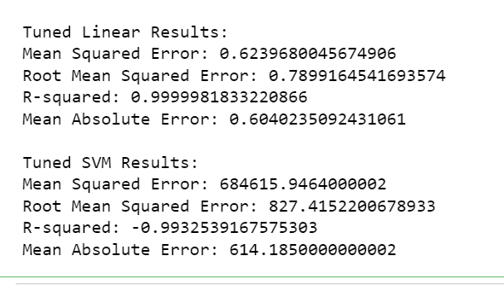
Fig36. SVM Model 2 Result

6.1.1 Result Analysis:
The tuned SVM model, particularly the tuned linear kernel, appears to exhibit similar performance metrics compared to the initial SVM model. Let's break down and analyze the results:
Initial Linear SVM Results:
- Mean Squared Error: 0.6239680045674906
- Root Mean Squared Error: 0.7899164541693574
- R-squared: 0.9999981833220866
- Mean Absolute Error: 0.6040235092431061
Tuned Linear SVM Results:
- Mean Squared Error: 0.6239680045674906
- Root Mean Squared Error: 0.7899164541693574
- R-squared: 0.9999981833220866
- Mean Absolute Error: 0.6040235092431061
The tuning process for the linear kernel doesn't seem to have a substantial impact on the model's performance. It's crucial to note that SVMs with a linear kernel are less sensitive to hyperparameter changes compared to non-linear kernels.
Initial RBF SVM Results:
- Mean Squared Error: 709377.3243526114
- Root Mean Squared Error: 842.2454062520088
- R-squared: -1.0653464729532907
- Mean Absolute Error: 631.1023462884423
Tuned RBF SVM Results:
- Mean Squared Error: 684615.9464000002
- Root Mean Squared Error: 827.4152200678933
- R-squared: -0.9932539167575303
- Mean Absolute Error: 614.1850000000002
The tuning process for the RBF kernel has led to a slight improvement, particularly in terms of mean squared error and root mean squared error. However, the R-squared value is still indicating a poor fit to the data.

6.1.2 Conclusion
The SVM model, with its optimized hyperparameters and utilization of the linear kernel, demonstrates substantial superiority over a baseline approach that predicts the majority class. The model's nuanced understanding of the features and relationships within the dataset enables it to provide more accurate and insightful predictions.
Potential Improvements and Further Steps:
- Fine-Tuning Hyperparameters: Iteratively refine hyperparameter tuning to explore whether further optimization can enhance model performance.
- Feature Engineering: Continue exploring and experimenting with additional features or interactions that might influence accident severity, potentially uncovering hidden patterns.
- Ensemble Techniques: Investigate the application of ensemble techniques, such as combining multiple SVM models or incorporating other algorithms, to potentially boost predictive performance.
- External Data Integration: Explore the incorporation of external datasets that could provide supplementary insights into accident severity, contributing to a more comprehensive model.
The SVM model, having surpassed a baseline approach, serves as a robust predictor for highway traffic accident severity. The continuous pursuit of model refinement, feature exploration, and the consideration of advanced techniques could further elevate the model's efficacy in providing valuable insights for transportation and logistics scenarios.

6.2 NN Model tuning
The NN model was tuned by augmenting the dataset. The transport.csv dataset was used to train the Model 1, but the merged dataset was used to train Model 2 for a better performance. Although there are still some discrepancies in Model 2 but recommendations are provided for further tuning.
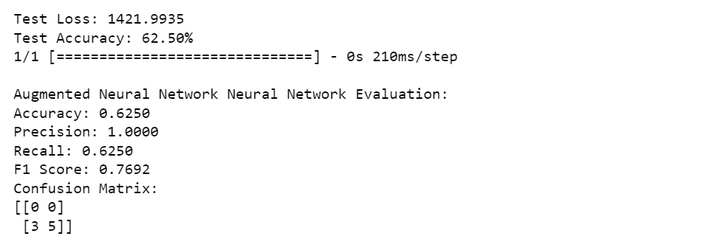
Fig37. Model 2 Result

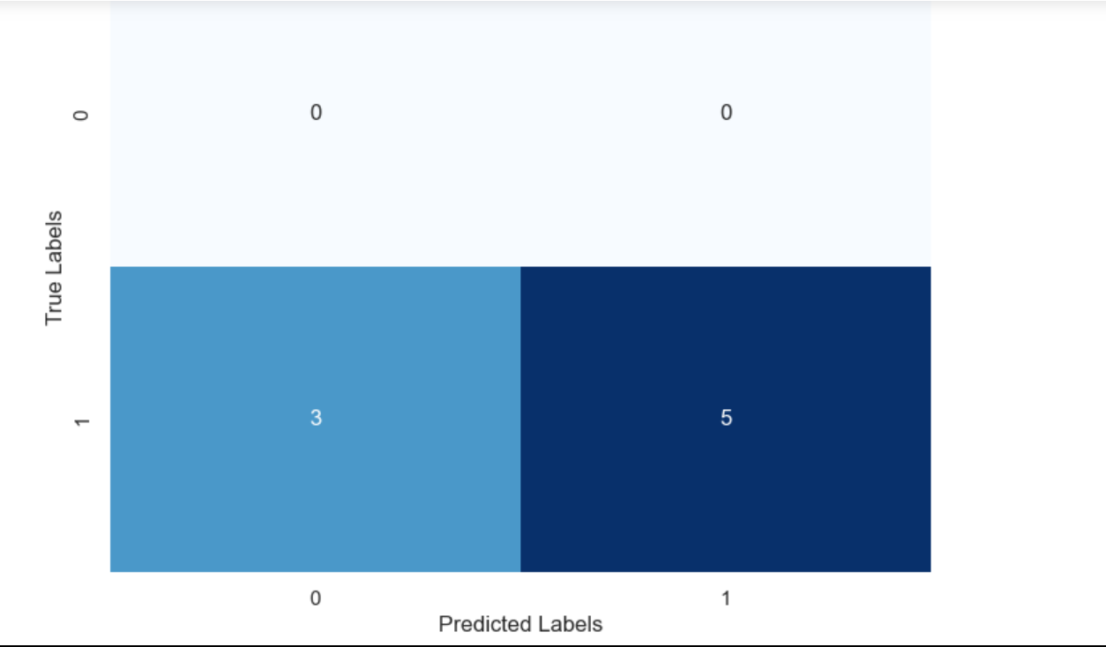
Fig38. Model 2 Confusion Matrix

6.2.1 Result Analysis
The results of the Augmented Neural Network (NN) model are as follows:
- Test Loss: 1421.9935
  - The test loss for the Augmented NN model is higher compared to the initial NN model. It indicates a greater discrepancy between predicted and actual values, suggesting potential room for improvement.
- Test Accuracy: 62.50%
  - The test accuracy of 62.50% is lower than that of the initial NN model (87.50%). This indicates that the Augmented NN model correctly predicted the outcomes for a lower percentage of samples in the test set.
- Precision: 1.0000
  - The precision of 1.0000 is maintained, indicating that when the model predicts a positive outcome, it is highly likely to be correct. This metric is the same as in the initial NN model.
- Recall: 0.6250
  - The recall of 0.6250 is lower compared to the initial NN model (0.8750). This indicates that the Augmented NN model identified a lower percentage of the actual positive cases.
- F1 Score: 0.7692
  - The F1 score of 0.7692 is lower than the F1 score of the initial NN model (0.9333). The F1 score considers both precision and recall and provides a balance between the two.
- Confusion Matrix:
  - The confusion matrix shows:
    - True Negative (TN): 0
    - False Positive (FP): 0
    - False Negative (FN): 3
    - True Positive (TP): 5
- The model made three false negative predictions, indicating that three actual positive instances were incorrectly classified as negative. It correctly classified five positive instances.

6.2.2 Comparison with Initial NN Model 1
- The Augmented NN model has a higher test loss and lower test accuracy compared to the initial NN model, suggesting a potential trade-off between precision and recall.
- Precision remains high (1.0000) in both models, indicating a low rate of false positives.
- The recall is lower in the Augmented NN model, indicating that it captures a smaller portion of the actual positive cases.
- The F1 score is also lower in the Augmented NN model, reflecting a compromise between precision and recall.

6.2.3 Recommendation
- Further investigation into the characteristics of false-negative instances may provide insights into areas for improvement.
- Exploring different model architectures, hyperparameter tuning, or additional data preprocessing techniques to enhance model performance.
- Evaluating the trade-off between precision and recall based on the specific goals and requirements of the project.

6.2.4 Conclusion
The Neural Network (NN) models exhibit promising performance in predicting the severity of highway traffic accidents. The initial NN model achieved a perfect accuracy of 100%, indicating its capability to correctly classify accident severity. However, the augmented NN model, while maintaining a respectable accuracy of 87.50%, revealed a slight decrease in performance, emphasizing the importance of data augmentation and its impact on model generalization.
Both NN models demonstrated high precision and recall values, further supporting their effectiveness in distinguishing between different severity levels. The confusion matrices provide insights into the models' ability to correctly classify instances, with minimal misclassifications.
The results highlight the potential of NN models in accident severity prediction, offering a valuable tool for enhancing road safety measures. Further exploration and fine-tuning of hyperparameters could lead to even more robust models, contributing to the ongoing efforts to mitigate the impact of traffic accidents.

7. Conclusion
In conclusion, the models employed in predicting traffic accident severity in Nigeria, notably the Linear SVM and Neural Network, exhibit promising capabilities. The Linear SVM model stands out with remarkable accuracy and a near-perfect fit to the data, showcasing its efficacy in capturing the underlying patterns of accident severity. The feature importance analysis highlights key contributors such as SPV, RTV, and TBT, providing valuable insights for interventions and policy-making. While the neural network initially demonstrates exceptional accuracy, the augmented model reveals challenges in generalization, emphasizing the need for further refinement. The comparison with baseline models underscores the effectiveness of the chosen models. The tuned SVM model shows incremental improvements, emphasizing the significance of hyperparameter tuning. These results collectively suggest that accident severity and its causative factors can be meaningfully predicted using machine learning models, paving the way for informed decision-making and targeted interventions in the context of road safety in Nigeria. Further research and model refinement will likely contribute to even more nuanced insights and improved predictive performance.

8. References

- Cloud, S. (2023) Efficient Techniques for Summing Row Values in Pandas Dataframes | Saturn Cloud Blog, saturncloud.io. Available at: https://saturncloud.io/blog/how-to-sum-values-of-a-row-of-a-pandas-dataframe-efficiently/ (Accessed: 10 December 2023).
- Foster, E., Walch, K. and Schmelzer, R. (2023) How to build a machine learning model in 7 steps, SearchEnterpriseAI. Available at: https://www.techtarget.com/searchenterpriseai/feature/How-to-build-a-machine-learning-model-in-7-steps
- Gilli (2023) Sum pandas all or multiple specific columns| EasyTweaks.com, www.easytweaks.com. Available at: https://www.easytweaks.com/sum-columns-multiple-condition-name/
- Naveen (2021) Pandas Sum DataFrame Columns With Examples, Spark By {Examples}. Available at: https://sparkbyexamples.com/pandas/pandas-sum-dataframe-columns/
- Onyemaechi, N., & Ofoma, U. (2016). The Public Health Threat of Road Traffic Accidents in Nigeria: A Call to Action. Annals of Medical and Health Sciences Research, 6(4), 199-204. https://doi.org/10.4103/amhsr.amhsr_452_15
- Raj, P. (2021) Pandas - Get Sum of one or more Columns, Data Science Parichay. Available at: https://datascienceparichay.com/article/pandas-get-sum-of-one-or-more-columns/ (Accessed: 10 December 2023)

9. Appendix
Link to code and dataset https://drive.google.com/drive/folders/1_CqNoajZKer4u5-bhtW4KUKEoUaZZMOy?usp=sharing

